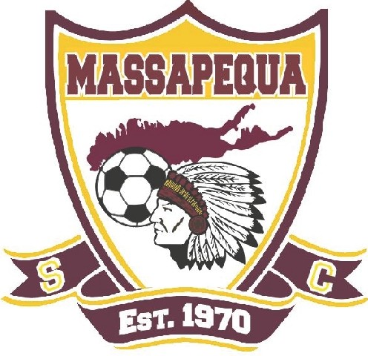
Massapequa Soccer Club 2022 Scholarship Application

Applicant Name _______________________________________ Tel. # (_____)_______________

Address
(Street)

(Town)

Place a check next to the programs that you have been involved in during your Massapequa Soccer Club career. If playing for another club, you may not apply.

□ MSC Player □ MSC Referee

Team Name ________________________________
Coach _________________________________
□ MSC Special Needs □ MSC lntramurals / Squirts □ Other (specify) _
Please ask the program advisors to fill out a Scholarship Recommendation Form that has been included with your application. Supply the advisor with a self-addressed and stamped envelope to the address below. They will return the form directly to the club. It is the applicant's responsibility to ensure recommendation forms are returned to the Scholarship Committee.

High School Attended____________________________
Name of college or university that you will be attending:

(Please attach a copy of your acceptance letter)

On a separate sheet, explain 1 - what the Massapequa Soccer Club has taught you, 2 - what you have done for the club. This must be typed and between 200 and 350 words. Do not include academics, involvement in school clubs and school sports. Remember to take pride in your essay. It counts.

Return this application before April 15, 2022 to:

Kathy Hillger
Applications Will Not Be 91 Harbor South
Accepted After Deadline Amityville, NY 11701
ATTN: Scholarship Committee – Confidential

Any questions please contact Lincoln Page at 516-241-2413

